Malitha Salpadoru Thuppahi

IT418 Project

**Problem Statement**

What is the perfect time to publish video that will most likely to trend?

**Research Methodology**

Dataset was obtained from Kaggle website. Dataset contained trending videos from end of 2017 to 2018. Python 3 environment was used to plot the graph containing likes and the time durations which the videos were posted. Few libraries such as numpy, pandas, scipy, seaborn, and matplot were used to plot the graph.

**Data Cleaning**

The dataset was cleaned using Microsoft excel for matching data types for published and trending dates.

Trending dates were separated into date, time, and hour. Published time was divided into month, day, and day of the week.

**Research**

The research is done to find out to obtain info about how to get videos into Trending list from an effective method.

**Results & Findings**

The research showed what time durations are the best to publish videos that will have a higher probability to be in the trending list.

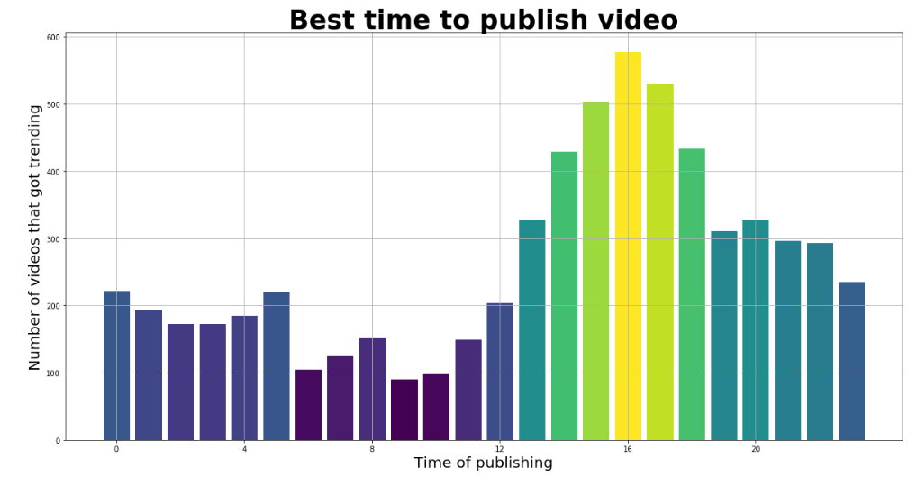

This shows that around 4 pm in the evening is the best time to publish videos which will gain the most likes and pushed into the trending list.

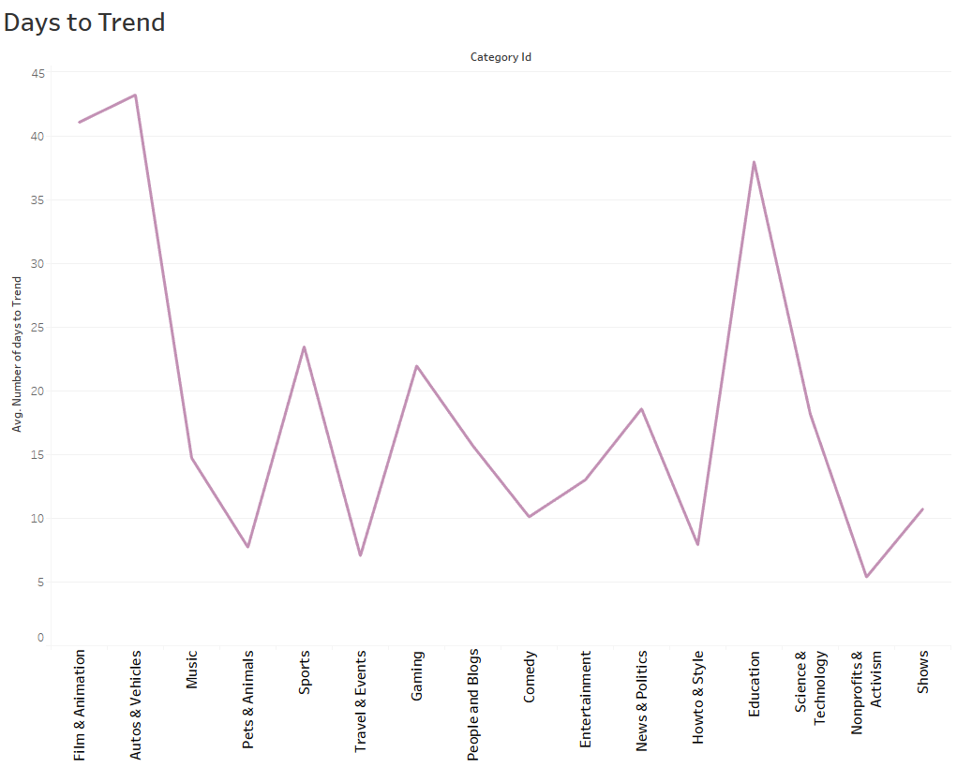

This graph shows the what type of videos takes least amount of days to trend in youtube. This graph shows the average days that a video takes to trend. It shows that Non-Profits and Activism takes least number of days to trend.

Travel & Events and Howto & Style takes the second place in the average trending days. Autos & Vehicles category takes maximum amount of days which makes auto and vehicles videos with least likes or views.

**Limitations**

The dataset only had the trending date without the trending time unlike the published time and date. The tags of the videos are filled up with unrelated and unwanted tags which can mess up the data cleaning and the analysis.